Group A
Experiment 4

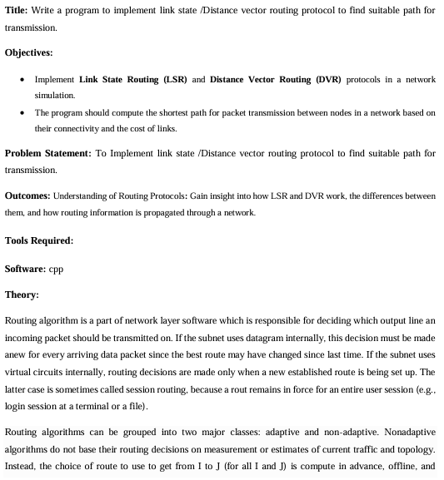
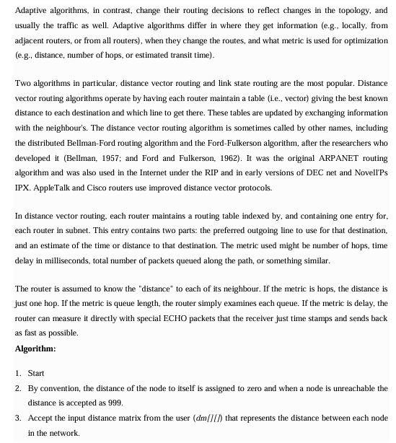
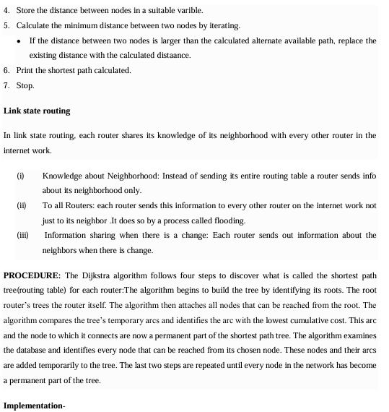

1. Structure Definition
struct node
{
int dist[20]; // Distance from this node to others
int from[20]; // Next hop router for reaching other nodes
} route[10]; // Array of up to 10 routers

Each router keeps:
- dist[]: distance to every other node.
- from[]: the next hop router to reach a particular destination.

2. Input Phase
int dm[20][20], no;
cout << "Enter no of nodes." << endl;
cin >> no;
cout << "Enter the distance matrix:" << endl;
- no = number of routers (nodes).
- dm[][] = distance (or cost) matrix between routers.
Then the program fills the routing tables:
for (int i = 0; i < no; i++) {
for (int j = 0; j < no; j++) {
cin >> dm[i][j];
dm[i][i] = 0; // Distance to itself is always 0
route[i].dist[j] = dm[i][j]; // Direct distance to j
route[i].from[j] = j; // Initially, next hop is destination itself
}
}

3. Distance Vector Algorithm (Core Logic)
int flag;
do {
flag = 0;
for (int i = 0; i < no; i++) {
for (int j = 0; j < no; j++) {
for (int k = 0; k < no; k++) {
if ((route[i].dist[j]) > (route[i].dist[k] + route[k].dist[j])) {
route[i].dist[j] = route[i].dist[k] + route[k].dist[j];
route[i].from[j] = k;
flag = 1;
}
}
}
}
} while (flag);
- This is iterative update of routing tables:
  - For each router i, check if going through another router k provides a shorter path to destination j.
  - If yes, update:
    - New shortest distance: dist[j]
    - New next hop: from[j]
  - Repeat until no more updates (flag becomes 0).
This is essentially Bellman-Ford algorithm applied for routing.

4. Output Phase
for (int i = 0; i < no; i++) {
cout << "Router info for router: " << i + 1 << endl;
cout << "Dest\tNext Hop\tDist" << endl;
for (int j = 0; j < no; j++)
printf("%d\t%d\t\t%d\n", j+1, route[i].from[j]+1, route[i].dist[j]);
}

Displays each router’s routing table:
- Dest: Destination node.
- Next Hop: the router to forward the packet to.
- Dist: shortest distance to that destination.

🔹 Example Run
If there are 3 routers with the distance matrix:
0 2 7
2 0 1
7 1 0
Output might look like:
Router info for router: 1
Dest Next Hop Dist
1 1 0
2 2 2
3 2 3

Router info for router: 2
Dest Next Hop Dist
1 1 2
2 2 0
3 3 1

Router info for router: 3
Dest Next Hop Dist
1 2 3
2 2 1
3 3 0

Conclusion: Thus we implemented Distance vector algorithm for finding suitable path for transmission.

